**CS 3132 Cloud Computing Lab Report (2024-25) (Jul-Dec)**

**Student Name: Aryan Vats**

**Registration ID: BT22GCS208**

**Section: C3**

**Email ID: Aryan.vats22@st.niituniversity.in**

**Assignment Date: 26-08-2024**

**Completion Date** *(when you completed the lab assignment)***:** *26-08-2024*

**1. Lab Assignment #2:** VirtualBox Network Setup and Configuration for Effective Communication - To set up a network using VirtualBox and configure network settings on multiple virtual machines for effective communication

**Objective**: The primary objective of this practical exercise is to equip participants with the essential skills and knowledge required to establish a network using Oracle VirtualBox and configure network settings on multiple virtual machines. This assignment is useful to gain proficiency in creating a virtual network infrastructure that facilitates effective communication between virtual machines. Through hands-on experience, participants will learn how to select and implement the appropriate network adapter types (e.g., Bridged, NAT, Host-Only) and assign IP addresses for seamless connectivity. This exercise will empower students with practical insights into network configuration within a virtualized environment, enhancing their ability to design and manage networks for various computing needs.

|  |
| --- |
| **Instructions**:   1. Create three virtual machines using VirtualBox. Choose any guest operating system (e.g., Ubuntu, Windows). 2. Configure the network settings for each VM:    1. VM1: Use Bridged Adapter    2. VM2: Use NAT    3. VM3: Use Host-Only Adapter 3. Assign unique static IP addresses to each VM based on the network configuration. 4. Ensure that all VMs can ping each other and access the internet (if applicable) based on the network settings. 5. Perform a simple file-sharing task: Share a file between VM1 and VM2. Document the steps and any issues encountered. 6. Write a lab report summarizing the network setup, IP configurations, and the file-sharing task. Include screenshots to illustrate the process. 7. Submit your lab report along with any configuration files you used. |

**2. Hardware Requirement:**

* **Multi-core Processor: A multi-core CPU (e.g., Intel i5/i7 or AMD Ryzen 5/7) is recommended for running multiple VMs.**
* **Minimum RAM: At least 4 GB of RAM is recommended, but more is needed depending on the number of VMs and their workloads.**
* **SSD Recommended: A solid-state drive (SSD) is highly recommended for faster read/write speeds, which improves VM performance, especially when multiple VMs are running or when large applications are used.**
* **Physical Network Adapter: For Bridged networking, a functional physical network adapter is required to connect VMs to the host's network.**

**3. Software Requirement:**

* **VirtualBox Software**
* **Guest Operating Systems (Supported OS versions for compatibility and performance.)**
* **Networking Components (Correct installation of networking drivers and VirtualBox Host Network Manager.)**

**4. Lab Tasks:**

**1. NAT (Network Address Translation)**

**Description:**

* **NAT is the default network mode in VirtualBox. It allows VMs to access the internet through the host machine’s network connection, but the VMs are not visible or directly accessible from the outside network or even from other VMs.**

**What You Can Do:**

* **Internet Access: VMs can access external networks, such as the internet, using the host’s network connection. This is useful for downloading software updates or accessing online resources.**
* **Basic Isolation: VMs are isolated from each other and from the host network, which can enhance security for internet-facing services.**

**What You Cannot Do:**

* **Direct VM-to-VM Communication:** VMs cannot directly communicate with each other. Each VM appears to be behind a separate NAT firewall, so they do not share the same network.
* **Direct Host-to-VM Access:** The host cannot directly access the VM unless port forwarding is configured.

**2. Host-Only Adapter**

**Description:**

* **Host-Only networking creates a private network shared between the host machine and VMs. This network does not provide internet access unless additional routes are set up.**

**What You Can Do:**

* **VM-to-VM Communication: VMs on the same host-only network can communicate with each other. This is ideal for private networks where multiple VMs need to interact without external network exposure.**
* **Host-to-VM Communication: The host machine can communicate with VMs on the host-only network, which is useful for testing or development purposes.**
* **Private Network: This setup creates an isolated environment where VMs can communicate securely without exposure to the outside network or internet.**

**What You Cannot Do:**

* **No Internet Access: VMs do not have internet access by default. You would need to add a secondary network interface configured with NAT or bridge mode if internet access is needed.**
* **No Access to External Networks: VMs cannot communicate with external networks or devices on the host network.**

**3. Bridged Adapter**

**Description:**

* **Bridged networking connects VMs directly to the host machine’s physical network. VMs appear as separate devices on the network, just like physical machines.**

**What You Can Do:**

* **Full Network Access: VMs have full access to the same network as the host machine. This means they can access other devices on the network and be accessed by those devices, provided they have appropriate IP addresses.**
* **Internet Access: VMs can access the internet if the host network has internet access, just like any other device on the network.**
* **VM-to-VM Communication: VMs can communicate with each other directly if they are on the same bridged network, which is ideal for scenarios where multiple VMs need to interact with network services.**

**What You Cannot Do:**

* **Limited Isolation: Since VMs are on the same network as the host, they are not isolated from other network devices. This might expose them to security risks if not properly configured.**
* **Requires Host Network Connectivity: The bridged adapter relies on the host’s physical network. If the host is disconnected from the network, the VMs will also lose network connectivity.**

**Summary of Capabilities:**

|  |  |  |  |  |
| --- | --- | --- | --- | --- |
| **Network Type** | **VM-to-VM Communication** | **Host-to-VM Communication** | **Internet Access** | **Isolation from Host Network** |
| **NAT** | **No** | **No (unless port forwarding is set)** | **Yes** | **Yes** |
| **Host-Only** | **Yes** | **Yes** | **No** | **Yes** |
| **Bridged** | **Yes** | **Yes** | **Yes** | **No** |

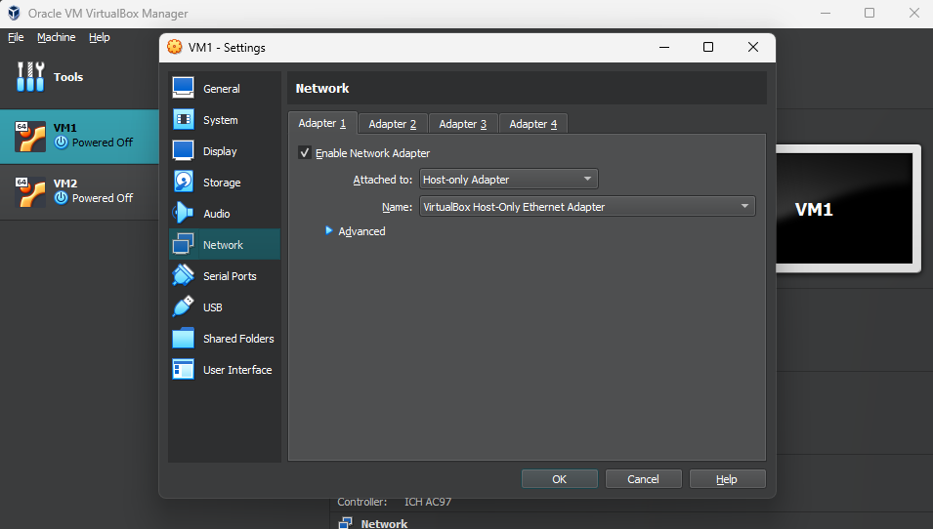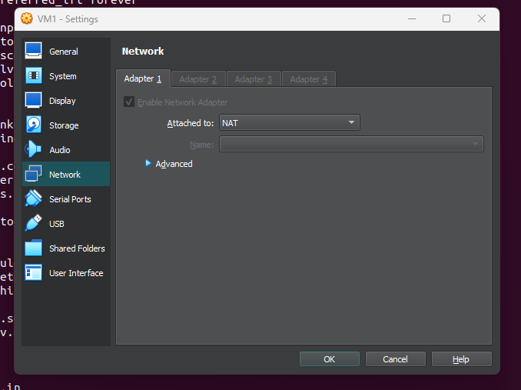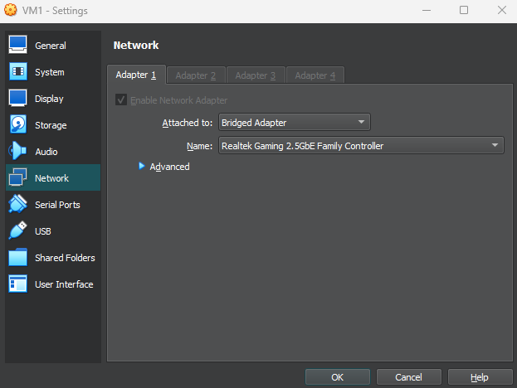

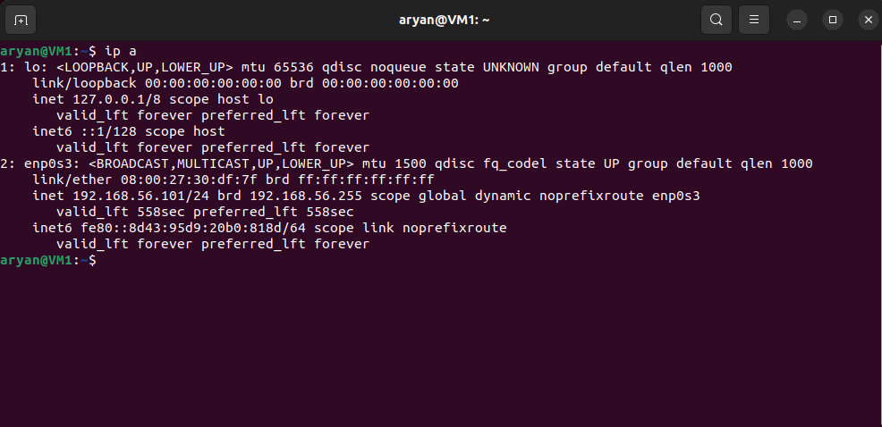

**(CHECK VM1 IP)**

**(CHECK VM2 IP)**

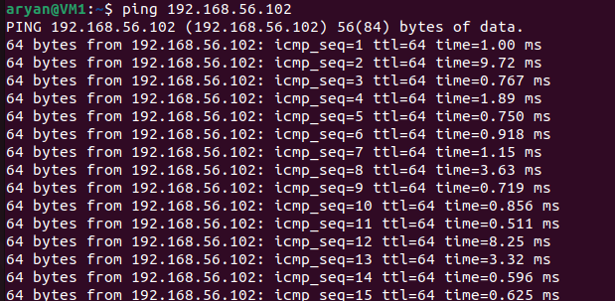

**(PINGING OTHER VM)**

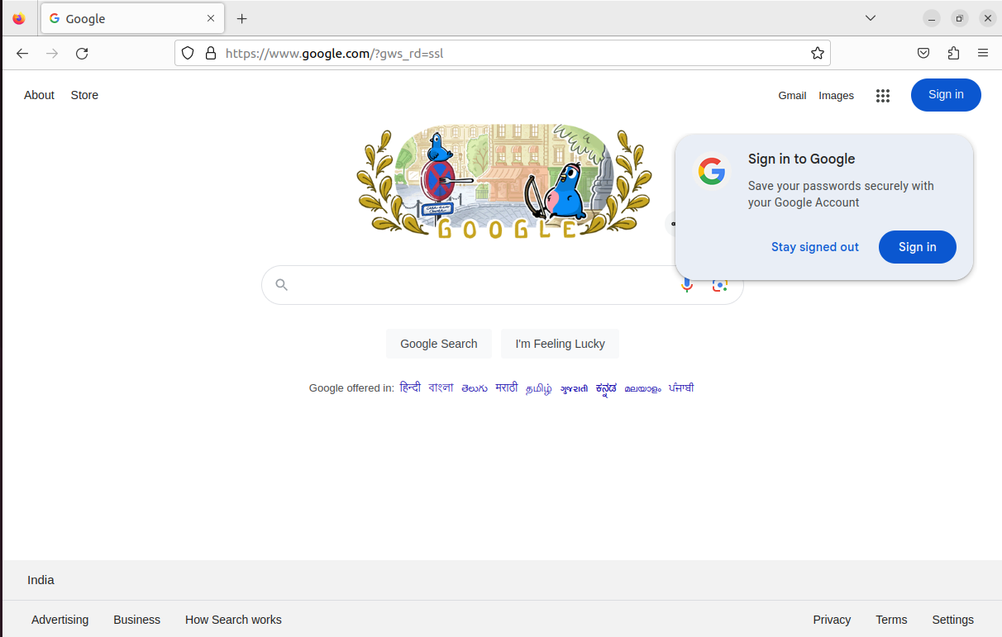

**(NAT INTERNET ACCESS)**

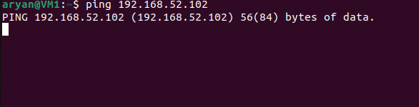





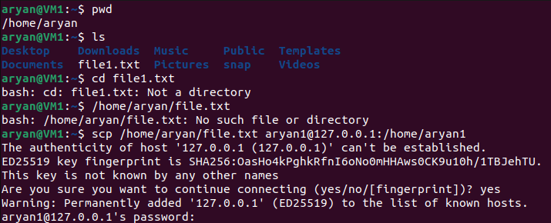

**5. Observations:**

**NAT:**

* **Observation: You may notice some additional latency due to the translation process of NAT. However, performance is generally adequate for internet access and simple network tasks.**

**Host-Only:**

* **Observation: Since this network type is limited to the host and VMs, latency is usually low, making it suitable for testing applications that require multiple VMs to communicate quickly and efficiently.**

**Bridged:**

* **Observation: Performance depends on the physical network’s speed and capacity. Bridged networks typically have good performance if the underlying network infrastructure is robust.**

**6. Results and Analysis:**

* **VMs can access external networks, such as the internet, without requiring any additional configuration.**
* **VMs are protected from external access due to NAT, reducing exposure to network-based attacks.**
* **NAT networks are ideal for scenarios where VMs need internet access but do not need to be accessible from other machines or VMs directly.**
* **Host-Only networks are highly effective for creating isolated environments where VMs need to communicate only with each other and the host.**
* **Bridged networks are ideal for situations where VMs need to function as independent devices on a network, such as testing network services, connecting to domain networks, or interacting with physical machines.**

1. **Conclusion:**

**When configuring networks in Oracle VM VirtualBox, the choice between NAT, Host-Only, and Bridged network types depends on your specific needs and use cases.**

* **NAT (Network Address Translation): Ideal for situations where virtual machines need internet access but do not require direct communication with each other or the host machine. This setup provides a high level of security by isolating VMs from the host and other network devices, making it suitable for environments that prioritize internet access while minimizing exposure to external threats.**
* **Host-Only Network: Best for creating isolated environments where virtual machines need to communicate with each other and the host but do not require internet access. This network type provides a secure and controlled environment, ideal for testing and development scenarios where internal communication is crucial, and exposure to external networks is unnecessary.**
* **Bridged Network: The optimal choice for situations where virtual machines need to operate as full members of a physical network, with direct access to all other devices and services. This network type is suitable for testing network services, integrating VMs into existing networks, or simulating real-world network scenarios. However, it requires careful security management to protect against potential vulnerabilities.**

1. **References:**

* **VirtualBox User Manual**
* **VirtualBox Networking Guide**
* **VirtualBox Networking Modes**
* **How-To Geek - VirtualBox Network Adapter Settings**

**10. Appendix:**

***Network Types:***

* ***NAT (Network Address Translation):***

***Purpose:*** *Allows VMs to access the internet via the host's IP.*

***Features:*** *No direct VM-to-VM or VM-to-host communication. Outbound internet access only.*

***Use Cases:*** *Safe internet access without exposing VMs.*

* ***Host-Only Network:***

***Purpose:*** *Creates a private network between VMs and the host.*

***Features:*** *No internet access, but VMs can communicate with each other and the host.*

***Use Cases:*** *Testing environments where VMs need to interact without internet.*

* ***Bridged Network:***

***Purpose:*** *Connects VMs to the same network as the host.*

***Features:*** *VMs have their own IPs and can fully communicate with other network devices.*

***Use Cases:*** *Full network integration and realistic testing scenarios.*

***Key Commands:***

* ***Check IP Addresses:***

*ip addr show*

* *Set Static IP:*

*sudo nano /etc/network/interfaces*

* *Transfer Files Between VMs:*

*scp /path/to/file user@destination_ip:/path/to/remote/*